**‘Fishtank Ltd’ CRM Cloud Migration –**

**Technical Design and Pricing Estimate**

Dear Mr Pothecary and Associates

We are privileged and honoured to be accepted as your partner in the cloud migration process of your CRM.

We appreciate that your CRM is absolutely critical to the core functioning of your business and that its existing form reliably serves its purpose for your current needs. As such, we shall set forth in this document a cloud architecture design and migration strategy that:

* Replicates, in the cloud, your existing on-premise architecture as closely as possible while simultaneously facilitating easy expansion for your long-term global growth goals.
* Minimises the chance of any downtime, and any associated financial or reputational risk

Kind Regards,

Christopher de Wardt

**CRM Cloud Architecture Diagram**

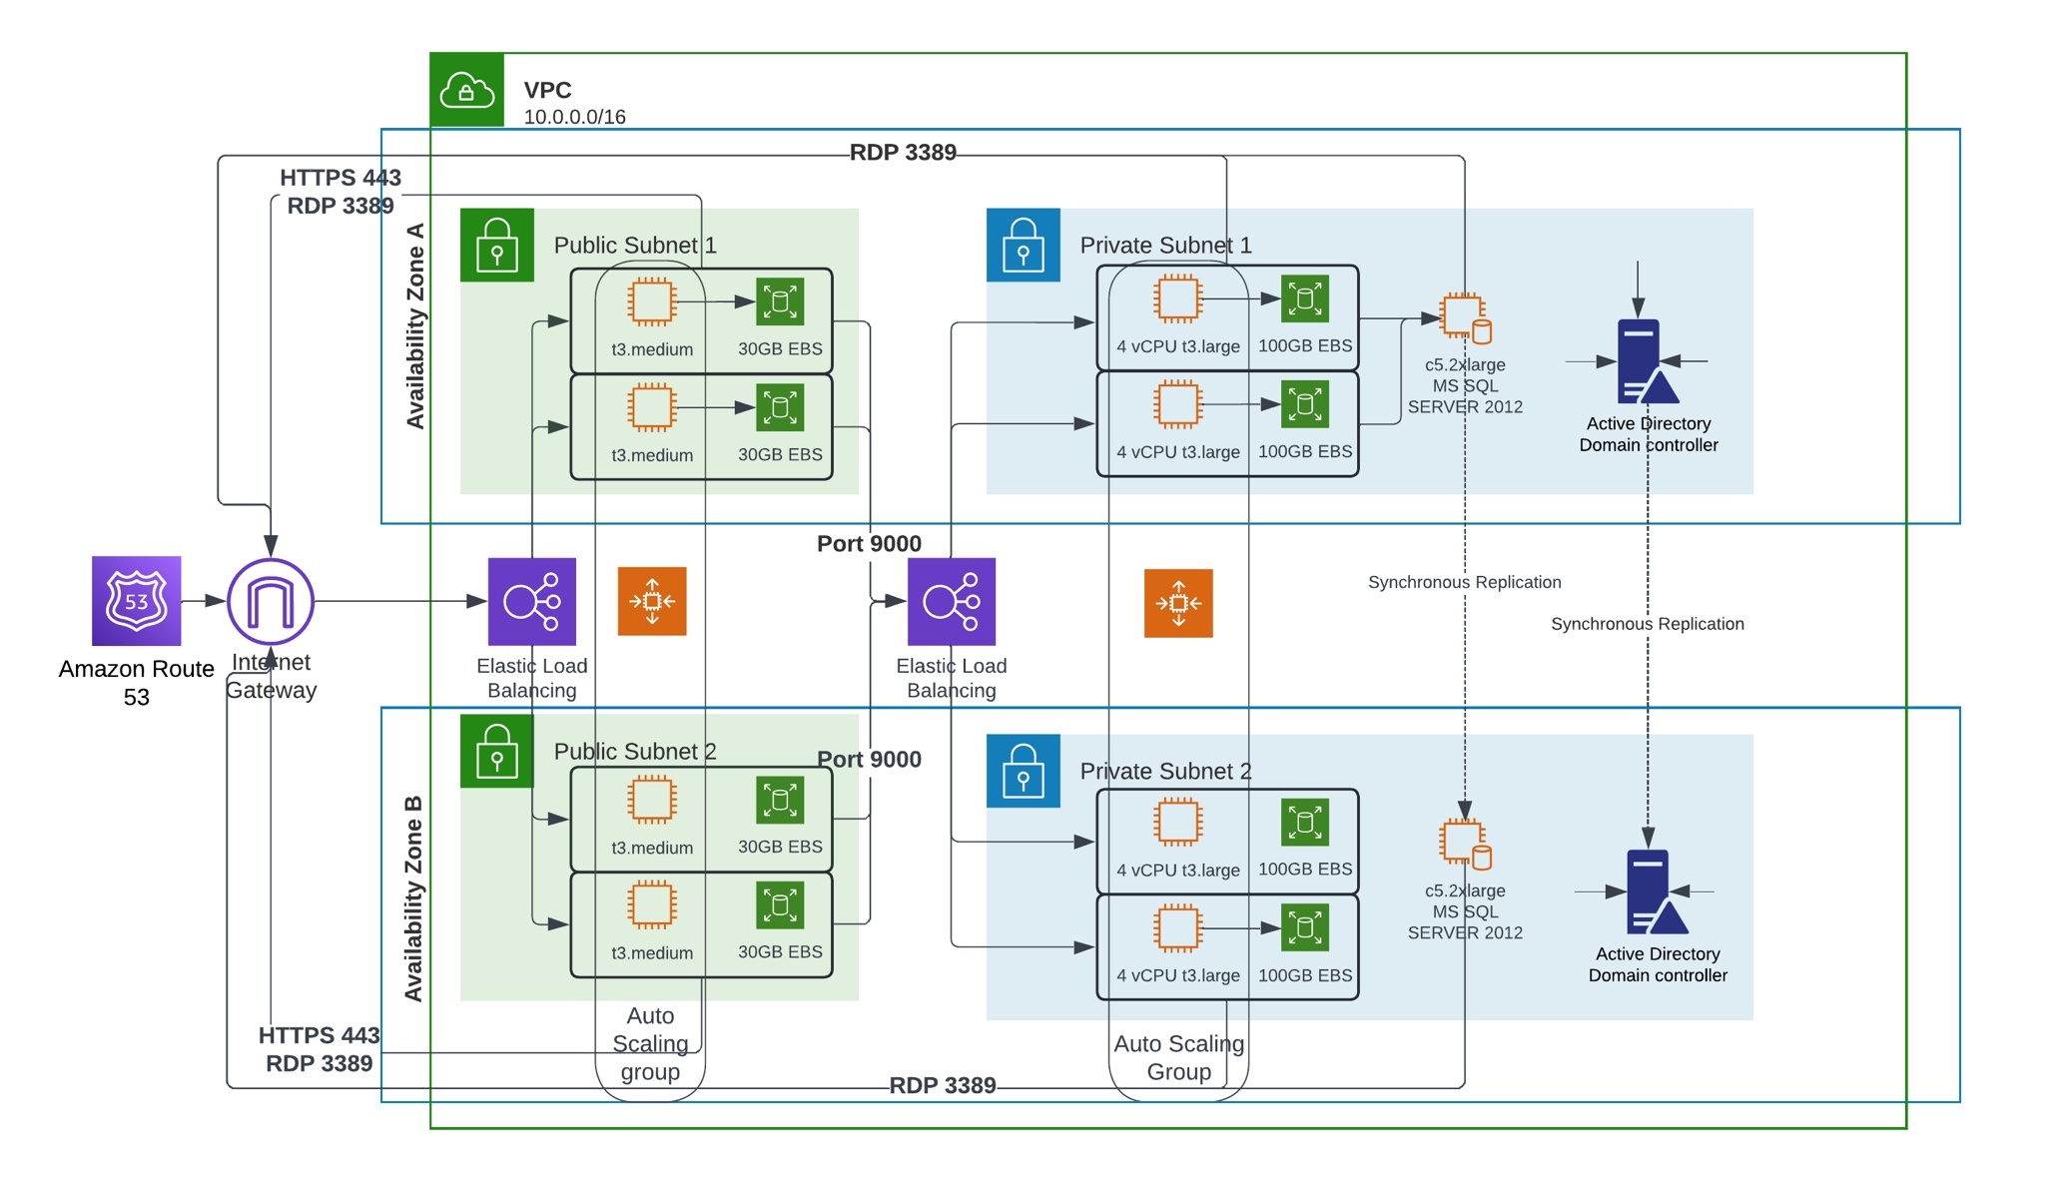

***Cloud Architecture Key Points****:*

1. The architecture is centred around the VPC (Virtual Private Cloud)
   * This virtual network is a secure structure within which your various services and infrastructure is deployed – this structure allows us to set up our own subnets and routing tables which provide a secure layer of isolation from the wider internet.
2. DNS functionality is provided by AWS’s robust Route 53 service – significant protection against DDOS attacks is provided as standard by AWS
3. The Internet Gateway controls the flow of all incoming and outgoing traffic between the Internet and the VPC
4. All your infrastructure is spread between two geographically distinct Availability Zones within your home geographical network region to provide greater fault tolerance in the event that one location develops any kind of issue
   * The resources are efficiently distributed by Elastic Load Balancers at both the Web Server and Web Application level according to demand
5. The infrastructure mimics your existing on-premise structure and specs of existing hardware – with the added ability to dynamically rapidly scale up your resources when demand is high (or you choose to expand) by equipping your EC2 computational units with the functionality of the Auto Scaling service. ie when CPU usage sustains a rise above 60% more computational instances will automatically be provisioned to reduce the risk of the computational resources being maxed out and bottle-necking your business activities
   * Furthermore, the specific t3 instances running on your VPC are ‘burstable’ and will immediately gain a CPU bump when demand suddenly surges
6. Your Web App servers are deployed within a private subnet addressable only from within the VPC. They are further protected by making use of Network Access Control List and Security Group functionality
   * The same goes for your Database and Active Directory servers which also reside within your Private Subnets
7. For added resilience, both your SQL servers and your Active Directory server have generally redundant copies kept in permanent sync across the two Availability Zones.

In order to implement this architecture, we will need to migrate your existing data from your data centres, before provisioning virtual computational units on AWS with that data. Any data obtained after the on-site transfer will be synced over the internet.

Once we have set up the cloud infrastructure, we will begin testing the new environment before gradually migrating your personnel to the new platform; keeping a careful eye out for any issues that may develop. We will be ready to roll back to your existing platform until we are satisfied we can ensure business continuity.

**Pricing Estimate Summary**

1. *ANNUAL* COST ESTIMATES payable to AWS for cloud infrastructure if paid upfront (for maintaining current scale of business)

| Component | | Specification | Annual Cost (£) | |
| --- | --- | --- | --- | --- |
| Web Servers | | 4x t3.medium instances | £1,308.67 | |
| App Servers | | 4x t3a.xlarge instances | £4,934.66 | |
| DB Servers | | 2x c5.2xlarge instances | £22,007.36 | |
| Active Directory Servers | | 2x c7i-flex.large instances | £2,112.38 | |
| Elastic Load Balancing | |  | £35 | |
| VPC Costs | 22 Working Days/month & 2 NAT Gateways | | | £97 |
| **TOTAL ESTIMATED ANNUAL AWS COSTS** |  | | | **£30495.07** |

1. Costs payable to Digital Futures Inc

|  |  |  |
| --- | --- | --- |
| Solution Architect | 10 days | £8,000 |
| Cloud Consultant | 5 days | £8,000 |
| Server Migration Engineer | 20 days | £10,400 |
| Database Migration Engineer | 15 days | £9,000 |
| First/Second Line Support | Full Time Equivalent | £52,000 |
| Third Line Support | 20hr/week Equivalent | £36,400 |
| **TOTAL SUPPORT COSTS** |  | **£123,800** |